Note: Include this page only when adding / amending / deleting a document. If using this document as a record, this Revision History page can be omitted.

REVISION HISTORY

Revision no | Date | Description of Changes | Reason for Revision | Revised by | Approved by
1 | 29 Nov 12 | - Add revision history page  - Add preparation and review of Monthly Service report | - Recommendation from Stage 2 audit  - Address CPIAR - IT_and_Training - 2012 - 0000171 | CMRojas
2 | Apr. 8, 2016 | Added disclaimer when printing the document | For document control | RCGanal | ARAlacar
TM-BR-MG- 11 Rev02, 10302015

- Objective
To ensure that IT infrastructure hardware are repaired in the shortest possible time.
- Scope
This procedure defines the action and responsibilities of the staff of the IT unit when major repairs for IT infrastructure are reported to the unit. This includes activities from the time a service request is submitted to the department until the time the repaired machine is either returned to the requesting party or disposed of .

- Definition of Terms
None.

- Procedure Details
RESPONSIBLE | ACTIVITY | INTERFACE
Technical support staff | 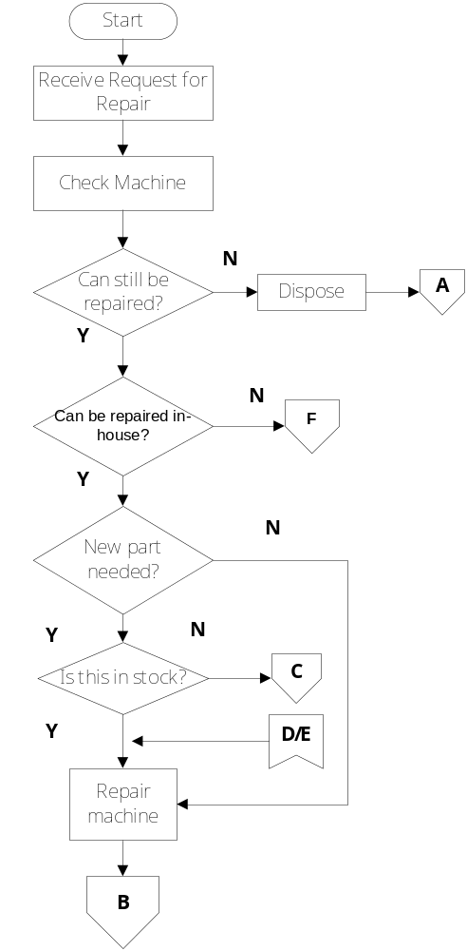 | Requesting Party  Service Request Form  Finance Head  Guidelines for Fixed Asset Management  Machine User manual

RESPONSIBLE | ACTIVITY | INTERFACE
Technical support | 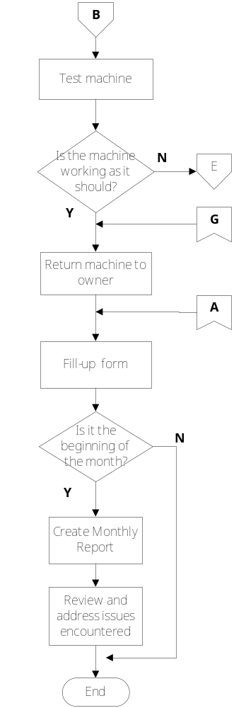 | Requesting party  Service request form  Monthly Service Request Report
RESPONSIBLE | ACTIVITY | INTERFACE
Technical support | 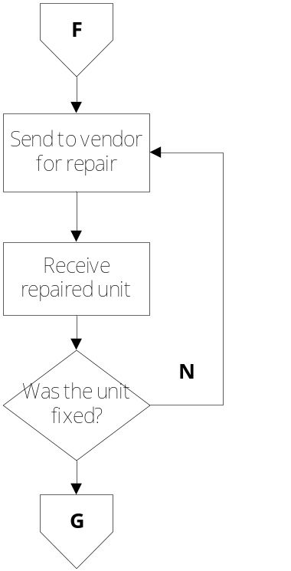 | Machine supplier/ Authorized Repair Center

RESPONSIBLE | ACTIVITY | INTERFACE
Technical support  Accounts Payable Staff | 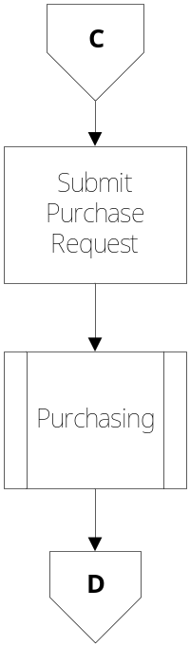 | Accounts Payable Staff/  Finance Head  Purchase Request Form  Suppliers  Guidelines for Purchasing

- References
- Machine User Manuals
- Guidelines for Fixed Asset Management
- Guidelines for Purchasing

- Quality Records
- Service Request Form
- Purchase Request Form
- Monthly Service Request Report

